Haddock –Haddies - Melanogrammus aeglefinus

Haddock are Scotland’s most popular fish – that’s the kind of fish you usually buy in the Fish and chip shop

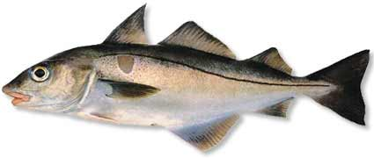 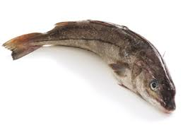 They are called fin fish because of the triangular shaped fins they have top and bottom that spread out when they are swimming in the sea.
The haddock is easily recognized by a black lateral line running along its white side
They also have a dark mark behind their gills called ‘St Peter’s thumb print’ . The story says that St Peter – a deciple of Jesus picked up a haddock to take a silver coin out of its mouth and left his thumb print on the fish.
There are lots of haddock round Orkney.

Cod Gadus morhua
They used to be scarce but are now very pelntiful around Orkney.

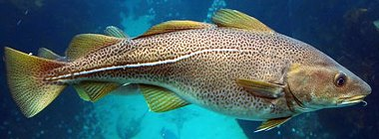

They have a white lateral line along their bodies and a tiny hook under their lower jaw.
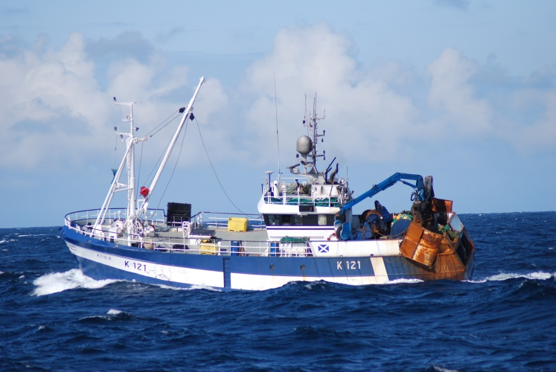
This Orkney boat the ‘Keila’ from Westray catches cod and haddock.
Cod is very popular in English fish and chip shops

