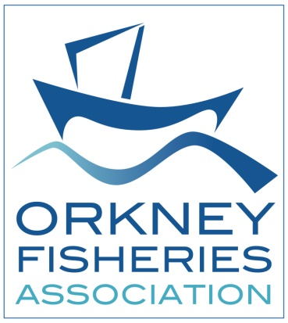
Shellfish that we catch in Orkney are called crustaceans

Shellfish Common names Orkney name Latin Name
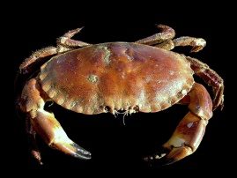 Brown Crab Partan Cancer Pagarus
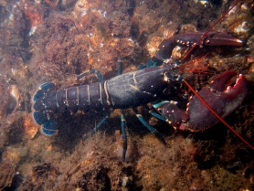 European Lobster Lapster Homarus Gammarus
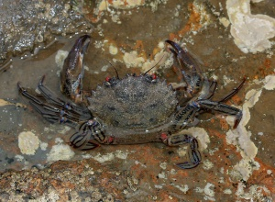 Velvet Crab – Devil crab Swiftic Necora puber
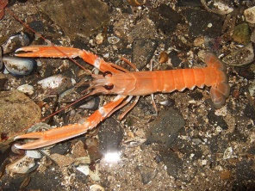 Norway lobster- Praan - Nephrop norvegicus.
Dublin Bay Prawn langoustine scampi
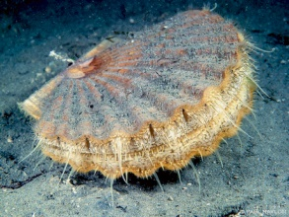 King Scallop – Clam Pecten maximus

