Predators are creatures that eat other creatures

These two can both eat shellfish – they look soft but they have very sharp beaks

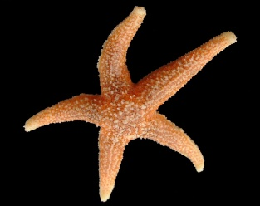
Common Star Fish –Asterias Rubens-
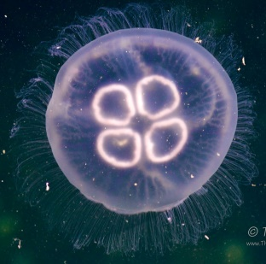
Common jellyfish - Moon jelly- saucer jelly - Aurelia aurita

